19.03.2008
Name :
Number :
CEM 121 DIGITAL LOGIC EXAM

( 12 ) |  | Convert the following numbers from the given base to the other two bases indicated  - (10101001,0101) ₂ =( ? ) ₈ = ( ? ) ₁₀  - (75,63)₁₀ = ( ? ) ₁₆ = ( ? ) ₂
( 10 ) |  | Perform the following arithmetic operation for binary numbers 11110000 and 00000101 without converting to decimal. The binary numbers are signed in 2’s complement system.  - Multiplication ( 8 bits result)  - Division ( 4 bits result)
( 10 ) |  | By using only Boolean Algebra, determine the following equation is valid or not
( 10 ) |  | Convert the decimal numbers 423 and 579 to BCD and add.
(10) |  | Convert the following Boolean expression into standard SOP and standard POS forms:  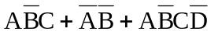
( 6 ) |  | Hexadecimal numbers F5 and 7C will be transferred with a parity bit. What is the odd parity bit?
( 9 ) |  | Give 3 advantages of using digital data over analog data.
( 5 ) |  | Gate A has t _{PLH} = t _{PHL} = 6 ns. Gate B has t _{PLH} = t _{PHL} = 10 ns. Which gate can be operated at a higher frequency? Explain simply.
(9) |  | Determine the signed 8 bits binary values of the numbers of the decimal -18 and +33 in the following systems:  - Signed-magnitude system  - 1’s complement system  - 2’s complement system
(5) |  | Convert the binary number 10011011 to Gray code:
(10) |  | Convert the decimal number 2,315 x 10² to a single-precision floating-point binary number.
(9) |  | Draw the output waveforms ( X , Y and Q ) for the following logic diagram.  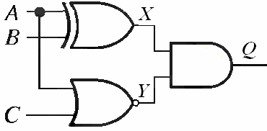  A  B  C  Y  Q  X

